Telecommunication Center “Science and Society” A.Joutchkov
Institute of Chemical Physics RAS N.Tverdokhlebov, S.Arnautov
Moscow State University I.Strizh
Federal Scientific Center “Institute of Immunology” A.Yanovsky, S.Golitsin
Institute of Molecular Biology RAS with gratitude to Y.Lyssov, A.Cherny
Institute of Biochemical Physics RAS with gratitude to S. Andreev

Federal Scientific Center of Virusology & Biotechnology “Vector”

and 30 institutions more …

in Grid Virtual Organization
“Russian Federal Scientific Project “New Generation of Vaccines
and Medical Diagnostics Systems”

Toward the Knowledge Network

Operational environment
(Globus)
- Databases
- Solutions Library
- Software Tools
- Streamline Data
- Knowledge Bases
- Ontologies Library
- Metadata Library
- Computational Elements
- Storage Elements
- …

- Security
- Administering
- Information service
- Job control
- File transfer
- …

Virtual Organization

Services Directory

Resources Directory
- Virtual Organization maintenance
- Grid-based calculations
- Data and knowledge mining
- Research maintenance
- Interdisciplinary services
- Visualization
- Web-portals maintenance
- Scientific publishing
- Virtual laboratories
- …

- Biomedical experts
- Knowledge management experts
- Computer technology experts

Libraries of Strategies and Ontology-driven Subject Area Models as “corner stones” in Grid Development

Grid-based calculations:

How to win conventional problem-specific solutions?

Problem-specific solution is always tuned just to a specific problem. And it solves the specific problem in the most effective way. But the only this specific problem.

Grid-based solutions are more universal. But they should not be to slow.
Efficiency of calculations is the key in choosing an appropriate solution.
Grid-based solutions should be able to adapt Grid resources to specific problems.

Local Library of Strategies does it.

We assume that an effective usage of Grid resources depends on correct actual information about accessible resources and on dispatching algorithm in equal degrees. Assuming that there are some mechanisms of correct actual description of resources we have concentrated on task and resources dispatching.
There are two approaches – to develop a universal Supervisor that could dispatch any sort of tasks and resources with reasonable efficiency or to develop a multitude of specialized supervisors which could dispatch specific sorts of tasks over definite resources in the most effective way. We believe that both approaches should be used in Grid environment. However, each of them has its own place in Grid hierarchy. Universal Supervisor is an appropriate solution at the high level of dispatching – by distributing tasks among Grid-nodes or ever segments. Specialized supervisors seem most appropriate tools to dispatch tasks and resources inside Grid-node (e.g., on computational cluster).
Universal Supervisors are being developed if framework of large-scale Grid projects. The very appropriate conception is proposed by EU DataGrid. The idea is based on developing a Library of Strategies that is used by Supervisor and the choice of the strategy depends on the task specificity.
We have extended this conception onto Grid-node level (computational cluster). Local Library of Strategies is a set of dispatching algorithms that use Grid-node architecture information as well as information on problem structure and optimal data distribution over the Grid-node. This information is warehoused in a special container - Local Metadata Repository.
Local Library of Strategies in Job Dispatching

Metadata Repository
cluster
node
cluster
node
cluster
node
cluster
node
Resource
Broker
Globus
Gatekeeper
Globus
Job Manager
Local
Resource Manager
Local
Library of Strategies
Create Jobmanager
Transfer RSL Job
RSL Job
PBS Job
node jobs
strategie 1
Grid Node
metadata

We have developed the Local Library of Strategies and have investigated methods of effective resource dispatching by developed Strategies in two computation-intensive problems – Alignment by BLAST for genomic and proteomic research and Monte-Carlo simulation of DNA fragmentations.
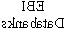
BLAST Testbed in RGrid
ITEP
IOC RAS
TC Science & Society Linux Cluster
SINP MSU
Supercomputer
Centre MSU
Gateway to
FREENET
Gateway to
COSMOS
Gateway to RUHEP
NRCS/IBMC RAMS
С3524
…
IITP RAS
RSSI RAS
M9 – International
Gateway
…
С3524
…
С3524
…
С3524
…
С3524
…
С3524
…
С550
…
FastEthernet
GigaEthernet
IGB RAS
ICP/IBCP RAS
EBI
Databanks
Windows Cluster
Bioinformatics Centre
EIMB RAS
Institute of Chemical Physics
Linux Cluster
Institute of Immunology
Linux Cluster

BLAST Testbed results
by different job and data dispatching strategies

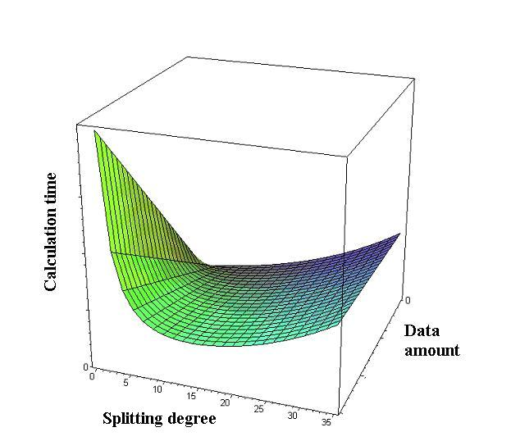
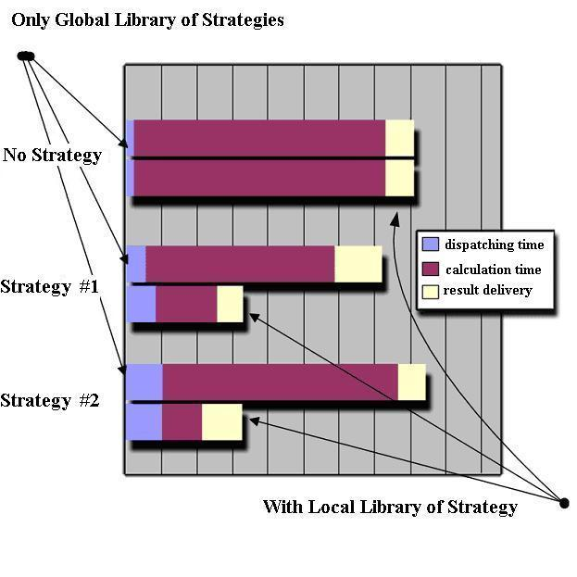

Monte-Carlo Testbed results
(Radiation Induced DNA Fragmentation)

Identical jobs with different initial conditions. No need to split data in a special way. No need to glue parts of results.
Small amount of input and output data - conformation parameters only (~32 Kbyte). Huge calculations.
The easiest Strategies – as much Computing Elements as possible.
1 job
calc time
12 jobs
calc time
Time
N nodes
1 node
12 nodes
(by identical Computing Elements)

Data and knowledge mining:

How to merge Information Resources ?

To much biomedical data. To many biomedical databases. Information mining in Data Space becomes a sort of Art.
We must convert these accumulated artistic skills into a science and then into a technology.
How to find information needed? How to find ALL information needed? How to represent information found?
How to build a collection for a Virtual Organization? How to assemble puzzle-like parts into a patient-oriented solution? How to build new knowledge?

Ontology and Metadata marriage provide solution. Grid provides middleware.

Since 1999 TC “Science and Society” in cooperation with Institute of Chemical Physics of Russian Academy of Sciences provides IT-support to more than 30 scientific medical and biomedical institutions in framework of Federal Scientific Project “New Generation of Vaccines and Medical Diagnostic Systems” (FSP). More than 20 databases different size and type of are tied up into an intact Information Space and thus constitute the Virtual Information Space of FSP.
How to unite all existed and future databases in a seamless manner?
Grid middleware promises to be an appropriate solution performing all technical procedures to maintain distributed cyber-resources. Biomedical databases are partially medical. Hence security and confidence in Networking are critical. Grid mechanisms of security, authentification, etc., are also appropriate.
Besides, Grid middleware should be hided from end-user because it is to complicate and perform mainly underlying technical tasks.
We assume that representing Data and Knowledge sources integrated by Ontologies we could hide all technical aspects of Information Space maintaining. We assume that such a technology of Data and Knowledge presentation will dominate in increasing extent. This technology let to integrate heterogeneous information resources on the highest level of abstraction in the most effective way.
Metadata in Dublin Core format form a new information level in Information Space and provide users of Information Space of FSP with valuable information about different information resources content.
Linking Information Resources based on Ontologies combines Concepts of the subject area and Links among them. The approach assumes local ontologies constructing by experts and then linking databases by ontology of supreme level that uses local concepts and relations of the databases ontologies as its own concepts. Cross-databases relations are elements of only this supreme ontology.
Besides, ontology is a sort of formal model of subject area. The presence of ontology provides to biologists a new vision of subject area and makes possible to formulate questions to Information Space in a more formal way. Presently experts of subject area play the key role in ontologies construction and linking concepts and data. However, we work on formal and informal algorithms development in order to perform the procedures automatically. We expect that there will be many ontologies soon and our next step in the technology development is to define a set of operations needed to manipulate with ontologies in a formal way.
Specialized tools developed to create ontologies in graphic form. These tools were implemented into Information Space of FSP and our experts have constructed ontologies dedicated to Immunology.
Corporative Data Space of FSP “New Generation of Vaccines and Medical Diagnostics Systems”

DNA-Vaccines Database
@ Institute of Vaccines and Wheys RAMS
DNA Anti-AIDS Vaccines Database
@ Biomedical Centre (S.-Petersburg)

metadata
metadata

metadata
Membrane Diagnostic Systems Database
@ Bach Institute of BioChemistry RAS
Virusology & Biotechnology Databases
@ Fed. Research Center “Vector” (Novosibirsk)
metadata
Viruses Database & Collection
@ Institute of Virusology
Immune Medicines & Clinical Tests Databases
@ Fed. Research Center “Institute of Immunology”
Corporative Knowledge Network
CONTROL CENTER
@ Institute of Chemical Physics RAS
metadata

metadata
Sintetic Vaccines Database
@ Shemyakin Institute of BioorganicChemistry RAS
metadata
More than 15 other Databases …

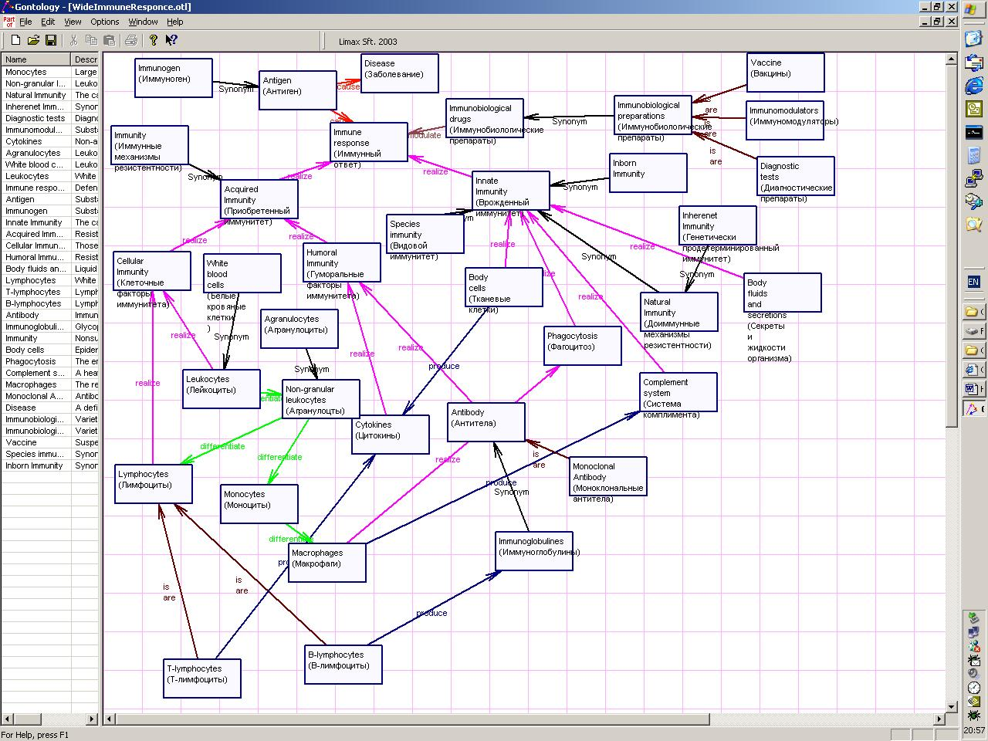
Instrumental tools
developed to build and
represent Ontologies
and Data Sources for
FSP participants
Instrumental tools:
To build and represent Ontologies and Data Sources

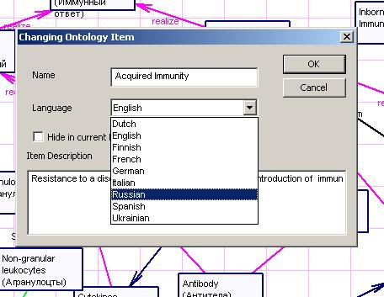
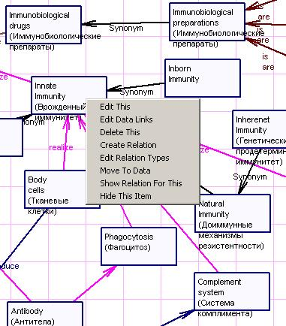
Multilingual support
Concepts &Links handling options
Different languages are used in open-source databases all over the world. Required language can be set for any ontology item – Concept, Links, Metadata …
Concepts and Links are the “bricks” of Ontologies. Sufficient set of operations on these “bricks” is provided.

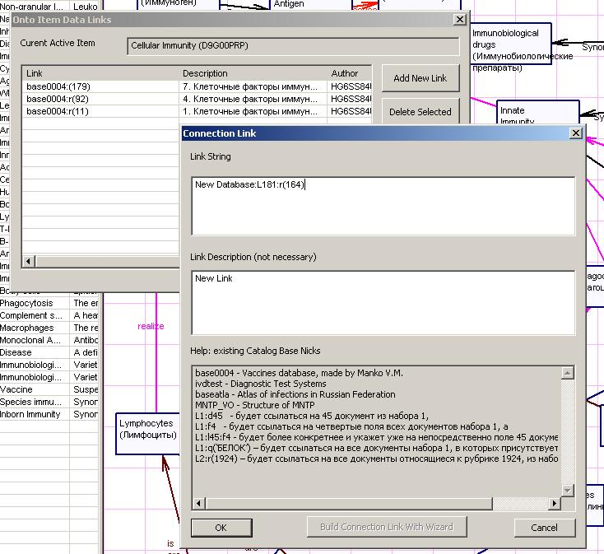
Concepts should be associated with elements of Data Sources. This provides a way to Knowledge management.
Link could point to different sort of Information Resource – record, column, table, database (including outer databases and their parts), file, Web-resources, etc.
Information Resource Metadata provide valuable information by linking.
«Concept - Data Sources» Links handling
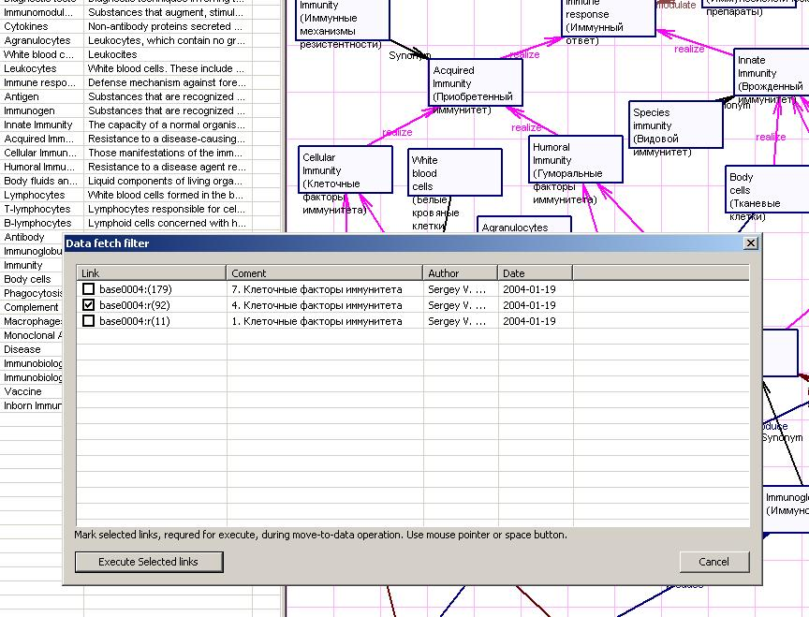

Indicate Links in order to access Data
Sources associated with the Concept.
Any number of Links can be chosen.
All marked Sources will be opened.
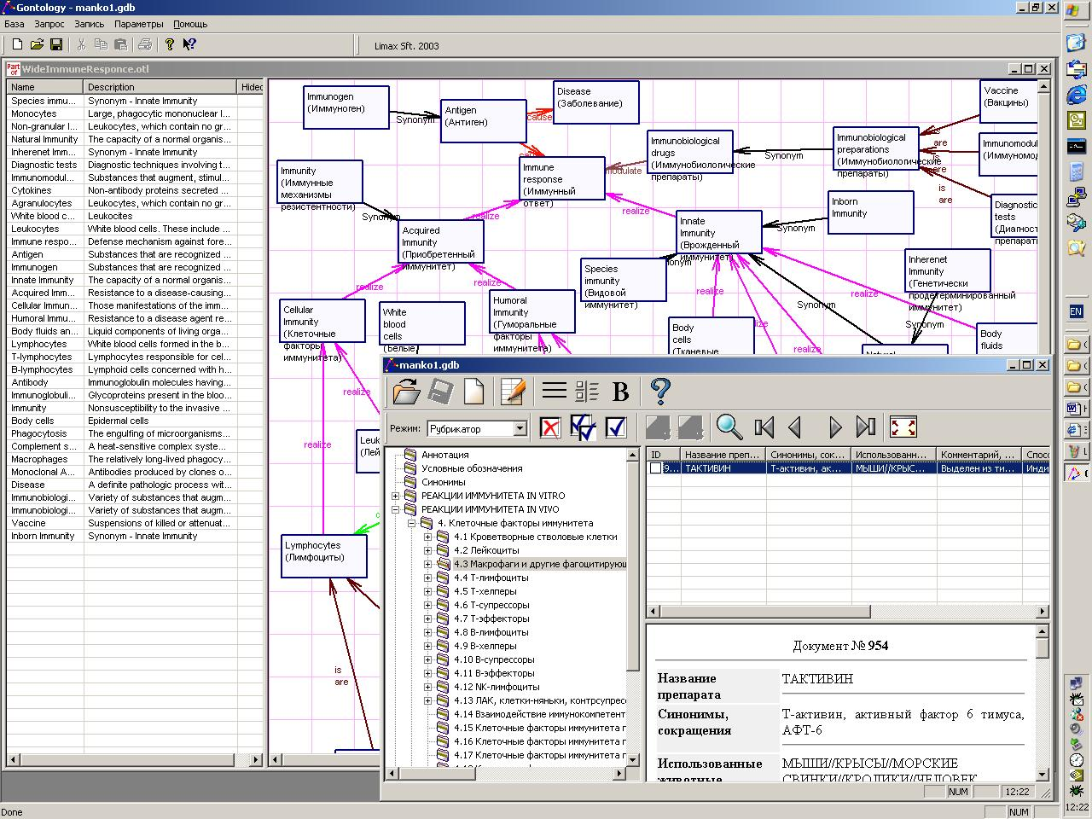

Appropriate database windows open
according to links selected

Unified interface is used to handle Ontologies
and Databases
Conclusions:

Ontologies not only let to link distributed data sources seamlessly but also let to construct formal models of subject area. These models are in turn the tools to formalize information requests and to construct intellectual queries to Information Space. There should be a multi-level hierarchy of ontologies and a critical mass of low-level ontologies must be reached.
Multi-level multi-lingual ontologies based on Grid-technology let to start integrating of national information resources into European Information Space.

Experiments with scientific problems that include both intensive computations and intensive data interchange have shown the efficiency of multi-level Libraries of Strategies. The research provides us with an experience in developing of effective Local Library of Strategies adapted to some large-scale biomedical problem.

Grid-based calculations of actual biophysical problem provide us with an experience of successful “gridification” and have shown that there are classes of problems that could be “gridified” in short time with the very reasonable efforts. The serious interest awaked in Biophysics and Biochemistry community to Grid is also the important result.
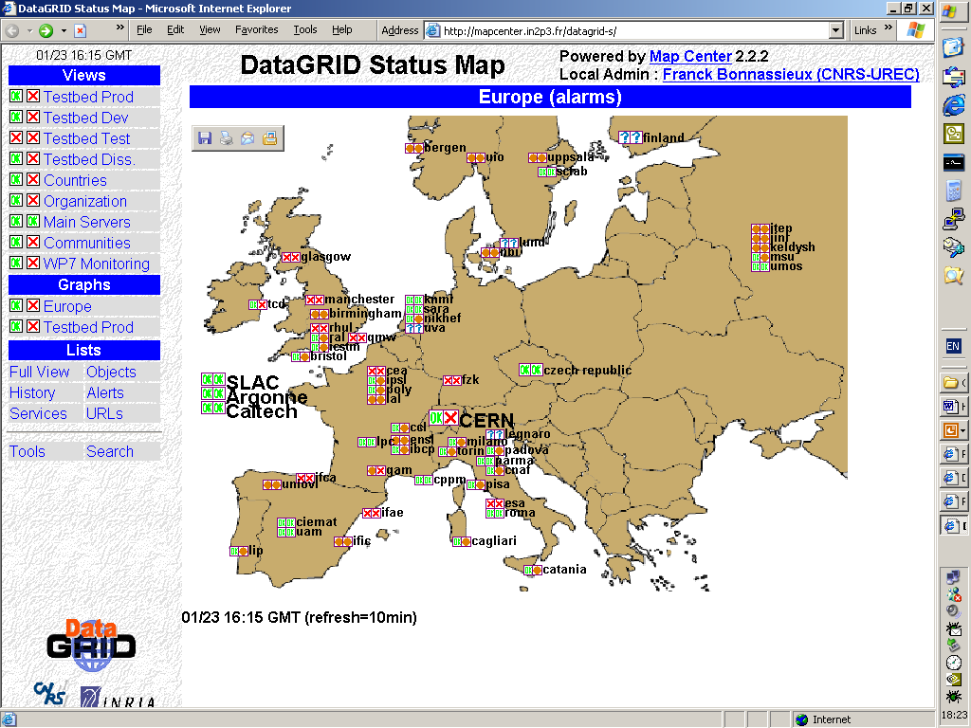

Contact:

Telecommunication Center “Science and Society”

Kosygina 4, building 11
Moscow 119991, Russia
Phone +7 095 135 60 20
Fax +7 095 135 78 46
e-mail rgrid@umos.ru
http://www.rgrid.ru

Special thanks to Russian Fund of Technological Development
at Federal Ministry of Industry, Sciences and Technologies

